**Scenario: E-Commerce Application**

Sample E-Commerce Application Architecture  
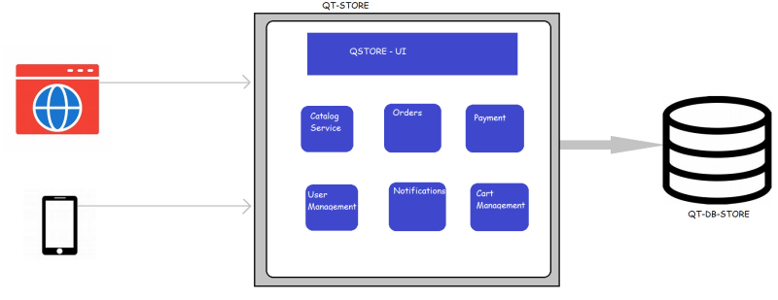

This application is developed using Java and to host this web application we need a tomcat server. The database is PostgreSQL

The architecture can be realized with minimum of two servers as shown below  
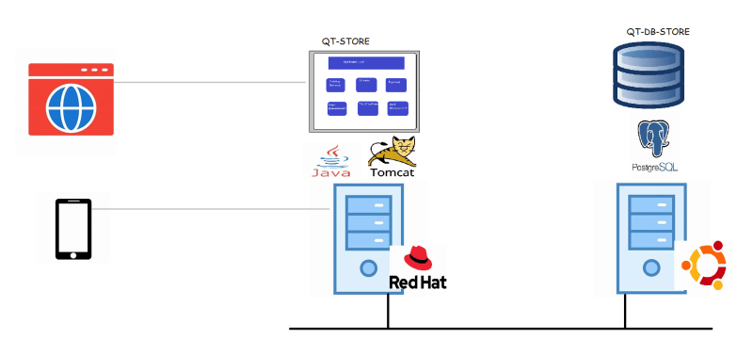

Challenges: Peak Hours:

Let’s assume our server can handle 5000 parallel requests per second, since we are running offers there is traffic with 20000 request per second

To solve this we scale the number of instances running our application as shown below  
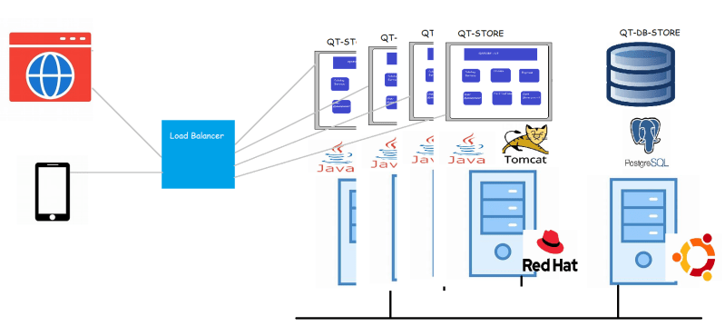

Let’s look at our application components, during peak hours only few components of our applications might be busy, but we scale the whole application which increase the amount of hardware resources such as CPU, RAM, Storage etc unnecessarily

This thought process has lead us to microservices.  
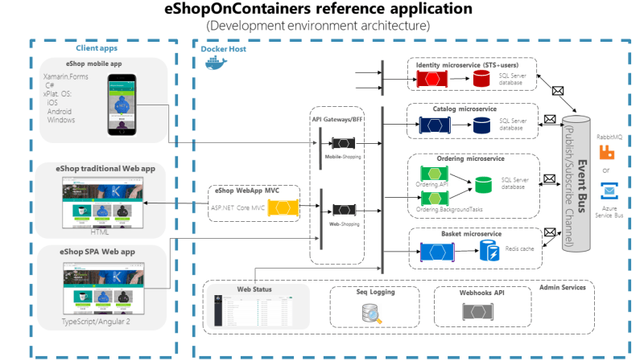

This concept expects scaling individual service components  
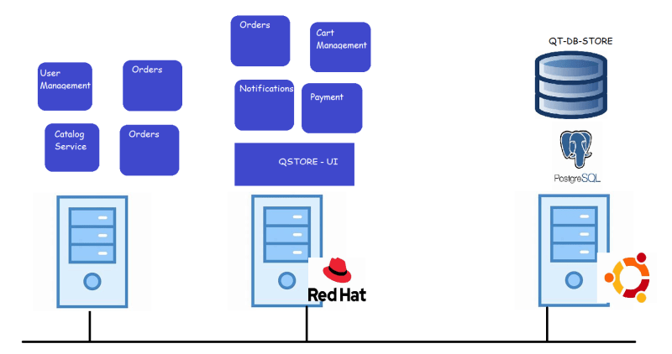

As we have seen in the class there is some software called as docker which can create multiple instances of the application by simply executing a command.

**Docker Inc**

* There was a organization called as dot cloud who were working on same PAAS application, to test this application they have created docker.
* Docker was made opensource and there was lot of community interest in Docker and then became organization’s major product.
* The organization was renamed as Docker Inc